**Session 15: SCALA - SESSION IV**

Assignment 15-1

**Write a simple program in Scala to show Simple Inheritance and Multiple Inheritance.**

1 – Write a simple program to show inheritance in scala.

Inheritance is an object oriented concept which is used to reusability of code. To achieve inheritance a class must extend to other class. Inheritance can be done by using **extends** keyword. A class which is extended called **super** or **parent** class. A class which extends class is called **derived** or **base** class.

**Scala Code**

**package** Assignment15_1

**class** Superclass *// Super or parent class, going to be extended by base class*

{

**val** *value1*:String = **"Assignment 15.1 example code"**

}

**class** baseclass **extends** Superclass{ *// base or derived class extends parent class*

**val** *value2*:String = **"Scala Single Inheritance"**

*println*(**"value1="**+ *value1*)

*println*(**"value2="**+ *value2*) }

**object** Main{

**def** main(args: Array[String]): Unit={ **new** baseclass()

}

}

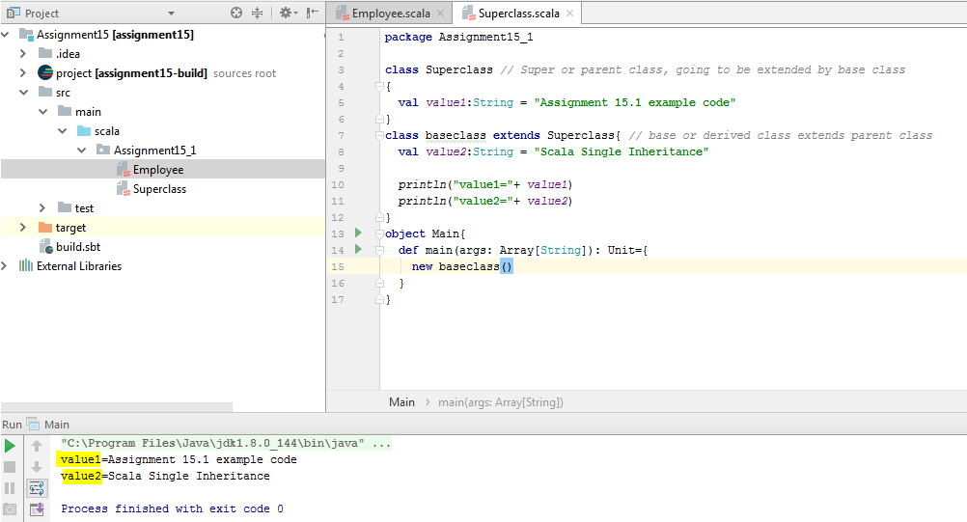

2 – Write a simple program to show multiple inheritance in scala.

Scala supports various types of inheritance including single, multilevel, **multiple**, and hybrid. You can use single, multilevel and hierarchal in your class. **Multiple** and **hybrid** can only be achieved by using **traits**.

Scala **doesn’t allow for multiple inheritance** but allows to extend multiple **traits**.

Traits are used to share interfaces and fields between classes. They are similar to Java 8’s interfaces. Classes and objects can extend traits but traits cannot be instantiated and therefore have no parameters. Traits in Scala are best described as “**interfaces that can provide concrete members**.”

package Assignment15_1

trait MultipleInheritance //parent trait

{

def show() // defining the function show()

{

println("Assignment 15.1")

}

}

trait one extends MultipleInheritance // extending the parent trait

{

override def show()

{

println("This won't be printed")

}

}

trait two extends MultipleInheritance // extending the parent trait

{

override def show()

{

println("Acadgild Scala Multiple Inheritance Example")

}

}

class three extends one with two //extending the base traits, calling the function

show()

object MainMulti{

def main(args:Array[String]): Unit ={

var c:three = new three // it will call last function which is mentioned in the

class three, changing the order will give different result

c.show()

}

Output

Example 1, here the class ***three*** calling the trait one with ***two***, the ***two*** in the last order and hence the function of ***two*** will be called and output is,

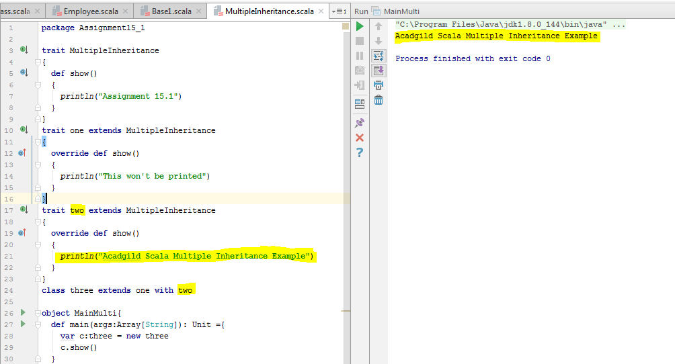

Example 2, in this example the object ***MainMulti*** called the trait ***one*** and see the result below,

